**DANCING WITH THE DEMON**

**(working title)**

**BY JAMES KENNEDY**

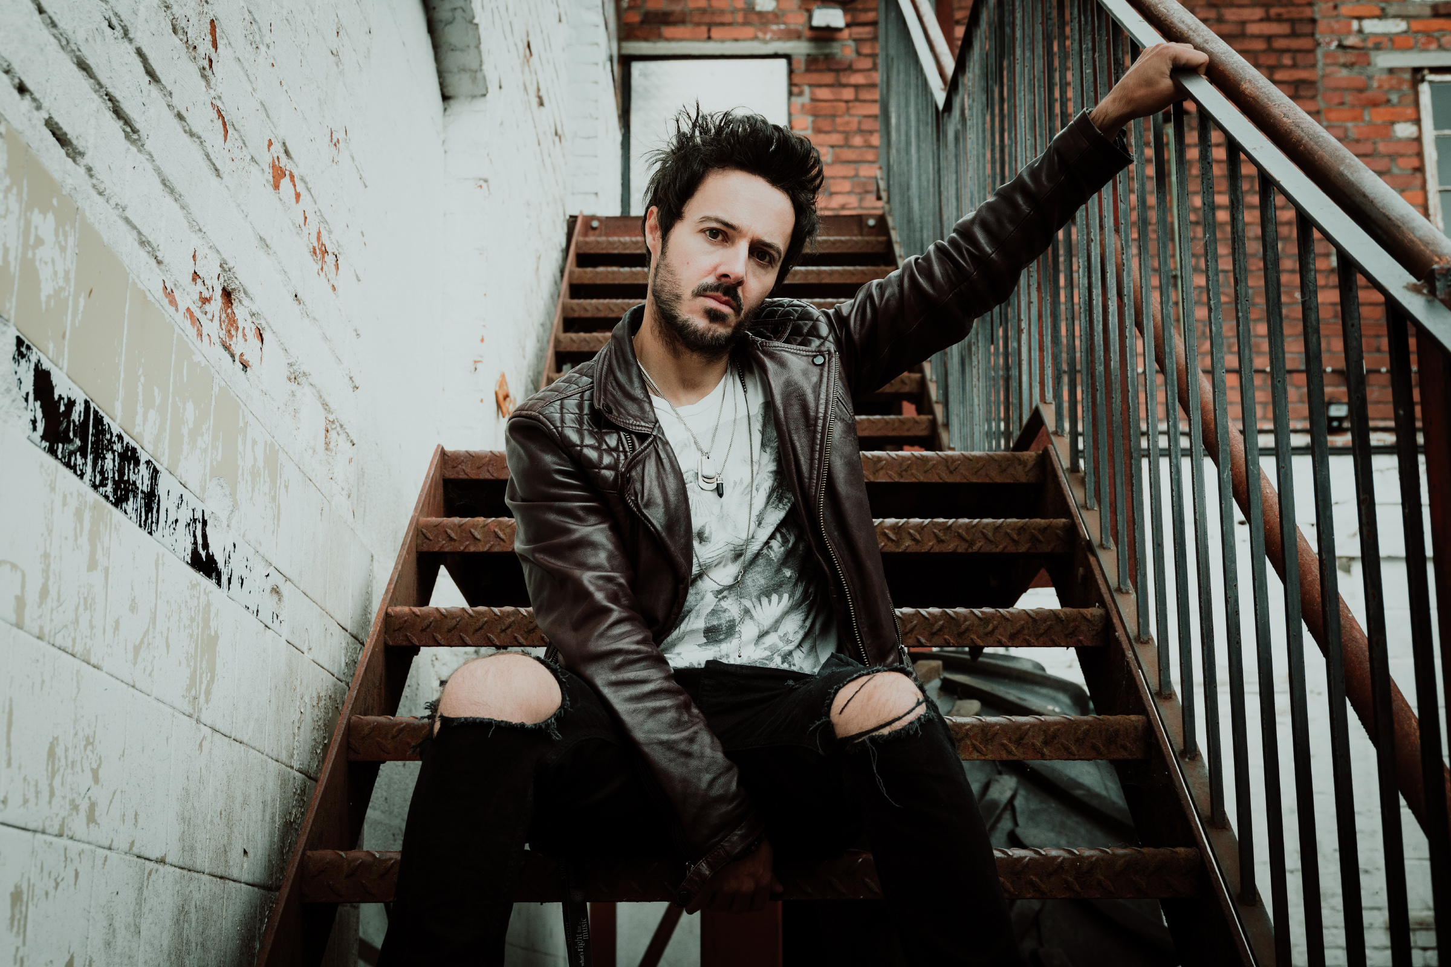

“*The way it is written will have you experiencing all the known emotions possible as this page-turner progresses and before you know it you find yourself at the back cover, wondering if it’s too soon to pick it back up and start again*”

**Rock'n'Load Magazine**

Submitted by:

James Kennedy

konicrecords@gmail.com

+44 (0)7929 347 472

**DANCING WITH THE DEMON**

**By James Kennedy**

It was all going so well. Good health, a happy family, a best selling book and a kick-ass rock’n’roll band. Life was sweet but then it had other plans. Enter the Demon. For a hardened rock music veteran, it was something that only happened to other people – softer people – not fast-living, high volume bad-asses like me. But the Demon struck fast and it struck hard, sending me on a ride to the depths of hell and back that rocked me to my core. I didn’t think I’d live to tell the tale - but I made it out alive and now I’d like to share that tale with you. It’s a tale not just about me but about you, about all of us and of course, it’s a tale about the Demon. Spoiler alert, it’s a tale with a happy ending, for the Demon may be a powerful enemy but it *can* be tamed - and I’d like to show you how. In case you’re wondering, the Demon has a name. It’s called anxiety.

**EXTENDED SYNOPSIS**

There have been many books written about anxiety, a fact which is surely a reflection of the growing scourge of the condition in our age of increasing stress and uncertainty. My book will aim to demystify and de-stigmatise the condition, explore solutions and share thoughts on the broader culture which is breeding this epidemic. Using my personal story as the through-line, the reader will ride with me as I experience anxiety for the first time, having to learn about it from a place of naive ignorance and eventually, after 2 years of self discovery, come out the other side a better person as a result. We’ll have some laughs along the way and maybe shed a few tears but ultimately the book will be a positive, friendly and constructive addition to the subject from the novelty vantage point of someone who never believed in anxiety until he got it. Not a medical expert or a self-help guru, but a fellow sufferer, someone who ‘gets it’. Someone who also happens to be a professional rock musician.

So why does a musician think they can write on this topic? I have spent most of my life in an industry that is synonymous with devastatingly poor mental health and whilst anxiety is new to me, depression and addiction are not. I have written extensively about both in my first 2 books and my song lyrics and I have contributed to several published articles on the issues. I have also been a direct witness to the scourge of anxiety and depression amongst my peer group and been a sounding board to countless people over the years who have reached out to me in private to share their fears and vulnerabilities but who wouldn’t do so publicly. I started therapy in my twenties and have been an active ‘self-developer’ ever since. I have read countless books on these subjects and been lucky enough to pick the brains of some brilliant thought leaders on my podcast. The fact that I am a musician, a man and an anxiety ‘first-timer’ is an advantage for this book for reasons I hope to explain below.

I didn’t know I had anxiety, I just thought I was dying. I’d been lucky to live for 40 years having never known a panic attack or anxiety and then almost overnight, I became debilitated with the most intense panic disorder that dominated my life for two years. Prior to that I was a cocky, fast-living, rock’n’roll musician who could strut around unfazed on any stage in the world but who was now unable to go to the supermarket or drive a car. What shocked me the most were the physical symptoms. I’d had no idea that anxiety could affect your ability to walk, to see properly or that it could cause real physical pain. I think that this sudden and extreme juxtaposition gives me an interesting perspective from which to understand anxiety relative to a so-called ‘normal life’.

My experience of anxiety was made more dramatic by my job. Having my first panic attack live on stage in front of an audience during a song, but not knowing it was a panic attack, was truly terrifying. It started a journey which saw me in A&E several times, pestering best-selling Neuroscientists, experimenting with a vast range of treatments from the medical to the outlandish, finding my inner hippie, meeting my younger self and learning more about myself than I’d ever known before. It’s been quite a ride – albeit, one that I never wanted.

But why is my story important? Because anxiety is rapidly becoming an epidemic. Stress, information overload, climate change, bad news, recession, war, economic uncertainty, growing inequality – it’s making us all more anxious then ever before. And then there’s social media. Because of social media, we all think that anxiety is only happening to us and not the glamorous, ever-smiling avatars of our friends online. So I think it’s important for people from all walks of life to share their anxiety truth unashamedly – especially those of us who are only seen haloed in stage lights and airbrushed promo pictures. It’s important because we need to realise that we’re not alone, that there is nothing ‘wrong’ with us, that there are very valid reasons why we feel this way and that there are indeed many practical and effective solutions already available to help us kill the Demon.

And this is especially important for men. Trapped as we all too often are within outdated notions of masculinity which make it difficult for us to admit our anxieties or seek help. A fact which is proven by the truly disturbing and heartbreaking truth that the biggest killer of all men under the age of 50, is suicide. We need to smash the stigma of anxiety and mental health struggles for men and work towards a ‘new normal’ where men can speak openly about their feelings without fear of ridicule. And I believe that people who are seen as being in positions of power, success or glamour have a vital role in shaping that new normal by de-stigmatising mental health for men openly, proudly and by speaking their language. I will devote a whole chapter in the book to this issue.

My personal story is dramatic and illuminating but ultimately it will only be the vehicle with which I relate to the reader, keep the pages turning and deliver the much more important mission of the book, which is to help people. To share the practical, effective and free tools that are available for managing anxiety and panic disorders, as tried and tested successfully by myself. This will include breathing exercises, meditation, exercise, substance control, therapy, thought management, supplementation, binaural beats and many others which I will discuss, explain and layout in simple, easy to follow instructions.

As well as my own personal experience with a panic disorder and my attempts at escaping it, the book will also draw from insights learned from the countless books I have now read on the subject as well as conversations I have had with many experts in the field on my podcast and the many medical professionals that I have spent time with over the past 2 years.

I want the book to be a valid contribution to the well-being genre, broad in scope but an easy read for a general readership. I’d like the book to be a constructive and empowering read for fellow sufferers but also an insight for non-sufferers like ‘younger me’ to be better able to understand and help those around them. The book will be personal, emotional and topical but told with my usual light-hearted, conversational and honest voice. There will be my standard digressions into related issues (social, political and personal) and digs at Coldplay. It will also be a tribute to the people who were there for me in my time of need. Similar books might be ‘The Subtle Art of Not Giving a Fuck’ by Mark Manson and ‘How to do The Work’ by Nicole Le Pera.

**BIOGRAPHY**

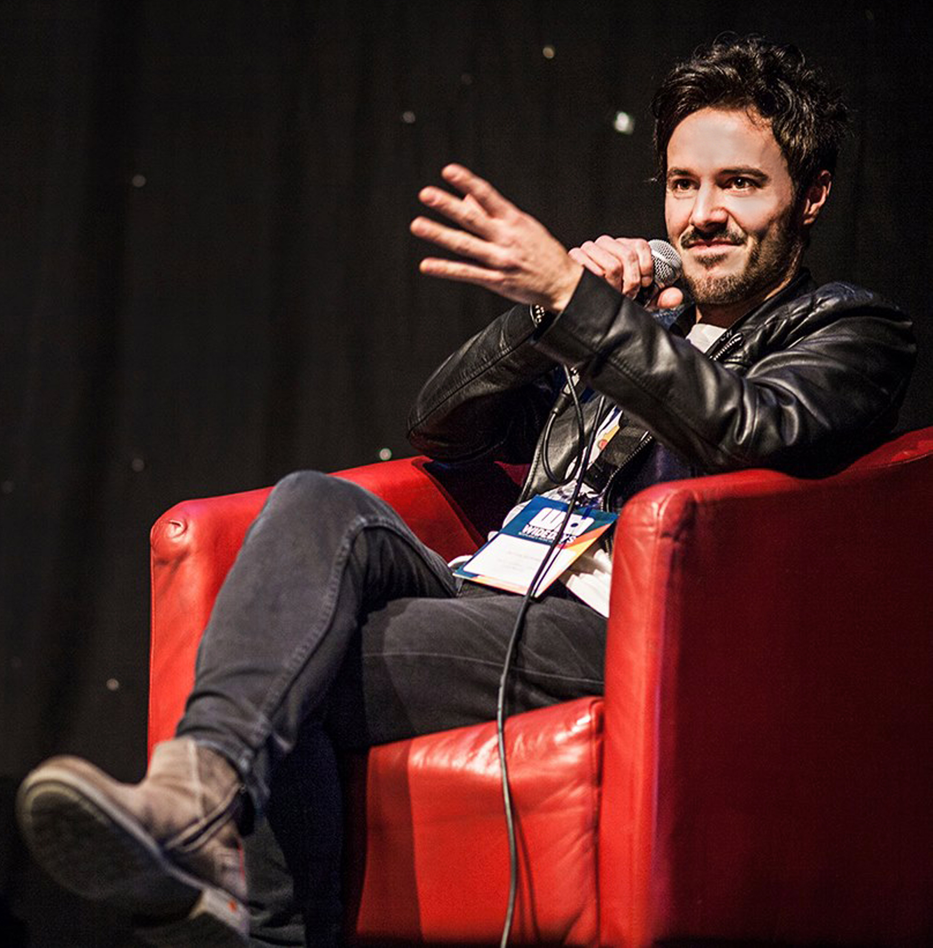

James Kennedy is a recording artist, podcaster and author of the Amazon #1 Best Selling rock memoir, 'Noise Damage' and the forthcoming, ‘Loud Medicine’ due to be published in June 2025. Active for over 20 years in the music industry, he has released 8 albums, played thousands of shows in many countries and currently fronts the rock band ‘James Kennedy and The Underdogs’. As host of the weekly ‘James Kennedy Podcast’, James chats with rock stars, politicians, academics and campaigners about a range of topics including mental health, nutrition, social issues, politics and more. Previous guests include :

Jeremy Corbyn (member of parliament)

Professor Tim Spector (health and nutrition expert)

Dr Dean Burnett (best selling Neuroscientist)

Sarah Wilson (NY Times best selling author and thought leader)

Bob Roth (meditation expert)

Luke Ambler (founder of men’s mental health charity, ‘Andys Man Club’)

Dan Gardner (NY Times best selling author of ‘Risk’)

Amongst many others. James has spoken in the House of Lords, the Wellcome Centre in London and several universities as well as music conventions. A keen user of social media, James has a good online following on all platforms and has featured in many mainstream magazines and radio stations including NME, BBC Radio 1, Sirius XM, Guitar Magazine, Trebuchet, The Big Issue, PRS Magazine, Metal Hammer, Radio Wales and many more. His latest book is the forthcoming ‘Loud Medicine – Dispatches from the Musical Underworld’ due to be published in the UK & USA in hardback by South Wales University Press in June 2025. He is based in South Wales but is most likely to be found on a stage...somewhere.

Social media following :

Twitter : 278,000 / Instagram : 5000 / Facebook : 11,100 / Mailing List : 7865

**THE MARKET**

I was actively involved in the marketing of my first book and as a result, I’ve had a good test-run for some of the things I can do to contribute to the promotion of my future books. Some of the things I contributed to the last campaign were :

1) Pre-release promotional content for my existing online followers, including daily countdown teasers, multi-media chapter readings, live stream readings, Q&A's, daily content posts, book quote graphics & stories on all social platforms.

2) Live streams plugging the book along with competitions and musical performances.

3) I organised many interviews, reviews and features with popular outlets like Face Culture, Metal Talk, Albumism, Guitar Magazine, Metal Hammer, Classic Rock, Sirius XM and others.

4) I ran several paid advert campaigns on Facebook and Instagram, targeted at the desired demographic.

5) I maintained the promotional momentum on my social pages for several months before and after the launch of the book, with reviews and features continuing to come in several months after the books release.

6) My 7000+ mailing list subscribers were directly emailed with a pre-order link ahead of the release.

7) The use of my podcast to talk about my upcoming projects before the guest interview. I can also do a series of subject specific ‘Podcast Specials’ around publication time, highlighting the issue (and the book) with special guests in the field.

8) The ability to incorporate my bands touring activities to directly promote my books both on stage and at the merch stand (promotional fliers, QR codes etc).

In terms of demographics, my current audience is 52% female and 48% male between the ages of 25 and 50 – mostly in the UK, USA and Australia. My podcast audience mirrors this also. The fact that ‘Dancing with the Demon’ incorporates autobiographical aspects which are an update from my previous book, ‘Noise Damage’ will appeal to my existing musical fanbase but I feel that the broader relevance of this new book will appeal to a new, non-music-specific audience outside of my current one. The non-academic tone of the book and widely relatable subject matter will likely resonate with a broad readership, including that demographic who are often not adequately catered for in the self-help, well being space – men. My intention is that the book will appeal to the broadest general readership.

I am willing and able to be pro-actively involved in the promotion of the book and my experience in the music industry enables me to make a 360 degree contribution to the campaign including the use of social media, the traditional media (magazines, radio and online zines), direct to fan marketing and live appearances. I am comfortable and experienced at speaking remotely and in front of a live audience. Given the nature of my previous writings and song lyric subject matter, I see no reason why ‘Dancing with the Demon’ would not cross-fertilize perfectly with the rest of my career activity and general brand identity.

**CHAPTER PROPOSALS**

1) Introduction

A brief introduction to the themes that lay ahead, my personal story and a promise that the book will bear some positive and useful information for sufferers and non-sufferers of anxiety alike.

2) Chapter 1 - The A Word

Exploring the subject of anxiety. What it is, what it isn’t, why it’s so prevalent today and why there is still confusion about it.

3) Chapter 2 - Men, we need to talk

Men need a whole chapter to themselves because men’s mental health is still a taboo subject and one that desperately needs to be more openly talked about. I’m not an academic or a hippie preaching at them, I’m a fellow sufferer and a proud, old school man so I think I’m well placed to have ‘the chat’.

4) Chapter 3 – My story

A deeper dive into the reasons that caused my panic disorder, including grief, an assault, decades of fast living and a mystery illness (it’ll have humour as well though, I promise).

5) Chapter 4 - The Road to Recovery

What helped, who helped. We explore neuroplasticity, therapy, hypnosis, meditation, yoga, nature, exercise, friends, hobbies, EMDR, acupuncture, medication and more.

6) Chapter 5 – The road to Hell

What didn’t help – alcohol, avoidance, rumination, stress, toxic people, rock’n’roll and coffee (gutted...)

7) Chapter 6 - Medication

Medication is a polarising subject, so we jump into it, looking at the pro’s, con’s, issues, concerns and benefits of medication whilst breaking the stigma of it and exploring my own journey with various medications and supplements.

8) Chapter 7 - Dire Diary

Actual extracts from the diary that I kept during my illness which perfectly conveys the vast range of ways that anxiety can manifest as bizarre physical symptoms. I hope this chapter brings some closure to those who (like I was) are still thoroughly convinced that they’ve got a rare brain disorder and not anxiety.

9) Chapter 8 - What my journey taught me

What positives did I get from the experience? What did it teach me about myself and about others? How has my life changed as a result of my time with the Demon?

10) Chapter 9 - Happiness INC

Some parting thoughts on the subject of toxic happiness and the fast paced, social media driven culture we live in which makes all of us feel inadequate and anxious. This chapter will be a celebration of our natural ‘human-ness’ in all its glorious messiness and reclaim our power from those who seek to use our normal-ness against us for a profit.

11) Chapter 10 – Resources, links and recommended reading.

**PRAISE FOR ‘NOISE DAMAGE’**

Amazon #1 best seller in Music Books, Heavy Metal Books and Punk Books.

Amazon #2 best seller in Rock Biographies

**“**The success of Kennedy’s magnum opus is unsurprising. It is a rejuvenating addition to the crowded shelves of rock autobiographies” **Guitar Magazine**

“Easily one of the greatest books I've ever read about music and being in a band”

**Eric Alper, Sirius XM, Canada**

“Hilarious and heartbreaking in equal measure (but then I *was* high when I read it)”

**Greg Palast, New York Times best selling investigative journalist**

“A journey through disillusion, the machinations of the music industry and hard-won self acceptance, it’s required, revelatory reading” **Metal Hammer Magazine**

“It’s relentless, it’s high energy, it’s enthralling” **Trebuchet Magazine**

“The way it is written will have you experiencing all the known emotions possible as this page-turner progresses and before you know it you find yourself at the back cover, wondering if it’s too soon to pick it back up and start again” **Rock'n'Load Magazine**

“Noise Damage stands out because it is remarkably well-written, with humour, humility, and insight” **V13 Magazine**

**“**An enjoyable, funny, emotional and painfully honest book that will appeal to both music enthusiasts as well as the uninitiated as it is an ode to magic of music and the way one’s life is enriched by it” **Scene Point Blank**

**SAMPLE CHAPTERS**

**INTRODUCTION**

OK, before we get started, I have a confession - I used to be one of 'those' guys. You know, those guys who just don't *get it*. For the first 40 years of my life, I'd never known the paralysing terror of a panic attack, I’d never had to battle through the day with the fist of anxiety around my throat and I'd never had to live with the cruel demolition that both can bring to ones confidence and enjoyment of life. Nope, I was one those cocky bastards who thought anxiety was for delicate little snowflakes and not bad-ass, alpha male, beer chugging, coffee guzzling, life-crushing legends like me. I’d say off-hand things to my anxious friends like "well if you're anxious, either do something about it or stop thinking about it. Simple" - stunningly ignorant to the fact that that is NOT how it works. Yep, I was pretty damn smug in my non-anxious days - and thoroughly clueless as to just how difficult everyday life was for so many of the people around me. That’s not to say that I was free of demons, however. I suffered with chronic stress, savage self talk, anger management issues and addictive tendencies - but these were all demons that helped me 'get shit done', so that was fine. After all, getting shit done is our primary purpose in life, isn't it - not happiness or good health. So on I raced at a million miles an hour, sleepless, multi-tasking, stressed out and frazzled – or ‘crushing it’, as it’s otherwise known. Until it happened.

You see, illness is a great equaliser. There’s no amount of bravado that can save you from the humbling smack-down that a good illness can serve you. You might think you’re unstoppable but nature might have other plans. I remember it perfectly – the moment the supermarket started spinning around me, its lights burning my eyes with an ice pick to the brain, the sudden and overwhelming feeling that I was going to faint or throw-up, right there at the check-out. After making it home somehow, all I could do to stop every sensory input around me – all light, sound and movement from sending my brain hurtling into a manic seizure - was to bury my head in a pillow, under a quilt, in a darkened room...and stay there for the next 12 hours. What the actual hell? Any idea of this being a random ‘one-off’ was quickly obliterated two days later when I tried to drive in the dark. Every oncoming headlight blinded me and shot an agonising pain through my head, throwing my brain into a state of wild shock – every few seconds for the entire journey, whilst I was behind the wheel of a fast moving car with some dickhead tailgating me. I’ve never been more scared in my life and I don’t mind admitting it. This, however, was just the warm-up.

Soon, even moderate light would send my brain into a kind of electrical frenzy. Daylight, the TV, the computer or the phone and driving now became an impossibility. That was month one. Then came the constant vertigo, the nausea, the frantic mental confusion, the debilitating physical exhaustion and weakness. My muscle wasted away and even walking became a struggle. Chronic headaches, dizziness and strange vision disturbances became my daily reality. None of this could compare to the absolute horror of the next addition though – the panic attacks.

I’d sailed free of these little beauties thus far in life but now I was getting them several times a day just sitting on the sofa. The sudden grip of fear and terror, the inability to breathe, the blood drain, the shakes, the palpitations, the confusion, the skin tightening like cling-film around me, my brain splitting into a thousand pieces, the desperate need to get the fuck out of here right now. I’d bolt awake at 4am with my heart punching out of my chest and a dizzying rush of adrenaline racing through my head so hard and so fast I could physically feel it. These attacks would strike at any moment, entirely unprovoked and without pattern and I quickly began living in fear of them and avoiding situations that would be unbearable should they strike again.

This wasn’t made any easier, course, by my job. I’m a musician. My ‘day job’ is to stand on stage, lit up in bright lights with a room full of people staring at me - and if I don’t do it, I don’t get paid. Not an ideal situation for someone with a newly acquired panic disorder, chronic light sensitivity and vertigo. It was brutal. So convinced was I during one show that I was having a stroke live on stage, that I walked off stage after three songs and went straight to A&E, only to be told after six hours of waiting...that I’d had a panic attack. Cancelling gigs is something I just don’t *do*. I’ve performed with Swine Flu, broken ribs, blood gushing out of my head and all manner of viruses and illnesses. But the panic attacks were so severe and so terrifying that cancelling shows soon became a weekly habit. And I didn’t care – anything to keep me safe from those satanic seizures.

After a few months of this, the ‘old me’ had become a distant memory. Rather than my usual racing around, getting shit done and kicking ass like a trojan (or so I thought), my days were now mostly spent laid up in bed, unable to do much else and frantically researching my symptoms. Was it a brain tumour? I had the symptoms. Some kind of autoimmune disease? Maybe it was Menieres disease, that could make sense. And on it would go. Guitar gadgets got replaced by blood pressure units and heart monitors - and plans, ambitions, passions and dreams quickly became irrelevant. For an active and busy man’s man like me, it wasn't long before the depression started creeping in. So tangled up was I in the misery of this mystery illness, that I became unable to do much else - like go to the shops, answer the phone, reply to emails or leave the house. It had gotten its teeth into me good and proper and I didn't even see it coming.

Yet according to all the tests, I was in great physical health. Brain scans, heart monitors, blood tests, eye scans, all showed a guy in top physical condition. And that just made it worse. Despite all my efforts to break the cycle and to keep doing physical exercise and regain control of my mind, it was futile. There was something wrong with me, that much was clear. But no one could tell me what it was. And it lasted for years.

Thus began my entirely unwanted relationship with an anxiety disorder that has changed my life. It’s been a profound journey that has taught me more about myself than I’d ever known before, forced me to make powerful changes and made me a much more empathic, compassionate and loving person. It’s made me be kinder to myself and more sympathetic to others. I ‘get it’ now. Am I glad I went through it? Shit no! But it’s given me some priceless life-gifts that have undeniably made my life better. So in the following pages, I’d like to share with you some of the stuff that I picked up on my journey to hell and back in the hope that it may help you out a little, too. And I promise I won’t make you wait for the good stuff - if you’re anxious already and seeking help then I’m not gonna make you wait in tense anticipation for 300 pages before we get to the useful stuff. I’ll keep it snappy, I promise.

Let’s jump in.

**CHAPTER 1 – THE A WORD**

Anxiety. A stunningly beige word for something so profoundly evil. We hear about it a lot these days although our grandparents don’t know what it is and think we’re all just being soft. It’s rife in almost every country and affects people of every social status. Over 30% of Americans will suffer a fully-blown anxiety disorder at some point in their life and at any one time, anxiety affects around 7% of the population. And it’s growing, fast. It’s also a broad church – with PTSD and Panic Disorders at the extreme end, the natural everyday stresses of modern life at the other and everything from OCD to social anxiety and phobias in between. Almost all of us will have been affected by this demonic little terrorist at some point or know someone who has - and certainly by now, everyone is at least aware of the evil A word.

Yet despite being a medically recognised illness, there are still the non-believers. I used to be one of them. Those who think that anxiety is a trendy buzz-word for a pampered, self-obsessed generation who wouldn’t last ‘two minutes in the real world’...or something. Those who think that anxiety merely means ‘feeling a little stressed’ but unable to deal with it like a real man. There is still a powerful social ignorance to the true nature of anxiety and it only makes the problem worse. Especially for men. Us men may not openly admit to feeling anxious or depressed but the truth comes out in the truly shocking fact that the single biggest killer of all men under the age of 50 is suicide. Read that again and think before making macho comments next time. This anxiety stuff is no joke.

The problem, I think...is the name. Anxiety. What the hell is that? That sounds like something you get before a flute recital at school – not the paralysing plunge into the devils choke-hold that I know it to be. We need to get that name changed, man. Perhaps something like ‘Involuntary Full-Body Terror Disorder’ (or IFTD) would be a better fit. You’d certainly get more sympathy from people if they thought you had that rather than the totally naff sounding ‘anxiety’. The other problem we’ve got is a cultural one. We live in an age which has some of its core values arse-backward. I’m talking about individualism, materialism and the toxic ‘happiness-industrial-complex’ - but we’ll get into *all* of that later on.

So why is this scourge so much more pervasive now than it was in our parents time? Is it because they were simply made of stronger stuff back then or is there something else at play? Yes. Yes there is. What the boomers are taking for granted is that yes, in their time they did have to eat asbestos or whatever and yes, I’m sure it was the maker of men but they also had a job for life with union protection, houses cost thruppence, they didn’t have to juggle three low-paid jobs, things were still manufactured here, there was a fair welfare state, free university education, no work on Sundays, you could retire at a good age with an honest pension, the world was simpler, life was slower, the climate wasn’t collapsing, Coldplay didn’t exist and they didn’t have social media making them feel like a loser 24/7.

We live in different times. Since our parents voted away the hard-won gains they enjoyed growing up because they didn’t want to pay the taxes, it’s been a world of ‘everyone for themselves’. With an explosion of inequality, the social safety nets trimmed ever smaller, the cost of living crisis, the impossibility of ever owning a home, a lack of secure employment, mounting debt and the merciless stress of a warp-speed modern life – is it any bloody wonder we’re anxious? I’d be more surprised if we weren’t. So people, please don’t take ‘snowflake’ comments from the generation who never knew a Zero Hour Contract and got to see Pink Floyd in concert for one shilling fifty.

Anyway, screw the unbelievers, let’s get back to that ‘Involuntary Full Body Terror Disorder’. What actually is it? What’s happening under the hood? What are the mechanics of anxiety and panic in the body and why does it happen? It’s important for us to understand this process if we are to ever wrestle the beast into submission and it’s essential that we appreciate that it *is* in fact just an innocent bodily process and not the wild, undefeatable bully that it feels like. So let’s break it down. Firstly, our brain doesn’t exist to make us happy, it’s evolved to keep us alive and if scaring the shit out of us is what keeps us safely indoors, then that’s what it’ll do. Our brains developed back in the days of roaming tigers, invading tribes, impending starvation and when a rustle in the bushes could mean your ass was toast if you hung around to think about it for too long. Literal life and death stuff. We may have the internet, central heating, nuclear weapons and obesity but our brain still thinks we’re scavenging in the bushes. So our brains are naturally primed to be a tad on the panicky side.

The first main cog in this machine is the Amygdala – often described as the brains smoke detector (because just like regular smoke detectors, it can have a tendency to freak out and scream its head off over nothing more than the cooking of a bacon sandwich). When it receives intel that something may be amiss (footsteps behind you, a noise downstairs), it goes into Red Alert instantly – no time to think about it. This immediately engages the body’s Fight or Flight system and prepares you to fight to the death or run for your life. The pupils of your eyes dilate to take in more light, adrenaline floods your body, you become hyper-aware of everything around you, your heart rate speeds up, non-urgent processes like digestion get shut down, your muscles tense up and you are ready to kick some serious ass. Rational thinking gets tasered by survival instinct and our internal caveman emerges ready for battle. Whether we’re about to fist fight a wild bear or we’re sat on the sofa worrying about our gas bill, our brains response system is the same. And it’s the only one we’ve got.

The difference is that Caveman was pretty chill so long as there was food in their belly and no one had been ripped apart by rabid beasts that day. Not much else to worry about. We on the other hand have got a shit load to worry about and our modern worries are with us all of the time. Bills, traffic, stress, jobs, competition, rushing, pressure, worry, exhaustion, screens, content overload, bad news, adverts, life coming at you without relent – our problems follow us around day and night, always churning away in the back of our poor, burned-out noggins. And because we’re using this old brain software in a world that it’s just not built to keep up with, our brains can’t tell the difference between *thinking* about being eaten alive by a pack of salivating bankers and actually having it happen. As a result, most of us are intensely ‘activated’ almost permanently these days, our internal smoke detectors jammed on full, and we don’t even know it. At least caveman got to dance naked around a campfire at night, we don’t do that – and we should.

If your Amygdala starts malfunctioning and sending you into high alert whilst you’re just sat watching South Park in your pants, you’ve got yourself what’s called an Anxiety Disorder. A very real and debilitating physical, emotional and mental disorder than can wreak havoc on your whole body. It’s basically a dysfunction of the bodies Fight or Flight system - a medical disorder in just the same way as diabetes is one, and it’s just as destructive to its host. Too much of that cortisol and adrenaline swirling around your body too often can cause a cascade of health problems including heart disease, high blood pressure, autoimmune diseases, cognitive decline, digestive issues, eczema and insomnia to name just a few. The old saying is true, you can worry yourself sick. Except, in the case of an Anxiety Disorder, it’s not the worry that gets you but the random misfiring of our body’s broken defence system. In that way, it’s very much like an auto-immune disease – overprotecting the host to the point of making them ill. And it’s bloody terrifying.

Understanding the nuts-and-bolts of the evil bastard though is all very well but what does it mean in reality? What does anxiety *feel* like? Well for those of you who have yet to experience the sheer delight of an anxiety disorder, allow me to demonstrate what it’s like with a list of all of the illnesses that I was thoroughly convinced I’d had whilst I was in deep with the old IFTD. Behold :

Brain cancer, schizophrenia, stroke, heart attack, brain aneurysm, Menieres disease, PPPD, intracranial hypotension, diabetes, autonomic nervous dysfunction, migraine, POTS, Long Covid, Fibro Myalgia, hypothyroidism, encephalitis...and god knows what else along the way.

Why? Well it certainly *wasn’t* because I had too much time on my hands but because on different days I had symptoms of all of them. Many times I rushed to A&E certain I was having a stroke or a heart attack and there were many nights when I’d go to sleep accepting that whatever condition I had was going to end me in my sleep that night. During my time with the demon, it would manifest as an array of physical pleasantries including delirium, vertigo, palpitations, balance problems, chest pain, blurred vision, slurred speech, panic attacks, head pressure, light sensitivity, migraine, light headedness, nausea, paranoia, insomnia, muscle pain, inability to breathe, exhaustion, cognitive decline, memory issues, eczema, ear pressure and feeling like my skin was tightening around me like a vice. All of them, out of nowhere and out of my control whilst I was desperately trying to just go about a normal days work. So real were the symptoms that for the longest time, I refused to accept that it could simply be anxiety and I kept digging for more clues that would unearth the true cause of my horrific condition – a venture that only served to further feed the beast. It was the scariest experience of my life, no contest. My hair even started falling out. That’s how real anxiety is.

Trying to function as a normal human whilst dragging all of this through your day is...let’s say...a tad challenging, and as some of you will know all too well, living with the ever looming threat of it striking at any moment will quickly take over your life. You start avoiding things. You start planning your life around it. You start living in fear of it and little by little, the ugly little parasite robs you of your fun, your ambitions, your confidence, your time and your power. It turns you into its pet. And if you dare forget about it for five minutes it’ll slap you dizzy right there at the supermarket check-out. Soon, you realise that resistance is futile and you just surrender to it’s cruel tyranny. Your world gets smaller. Your light dimmer. Your potential pacified. Like an abused spouse, you do whatever you have to to prevent pissing off your master - forever tip-toeing around it, living by its rules and within its boundaries. First it steals your health, then your attention and then your social life and career. It wants you all to itself. Full spectrum dominance. You cancel on friends, you pull out of opportunities, you make excuses to family, you drink too much at parties and because nobody can see your illness, they just think you’re being a selfish arsehole. It’s true, I’ve been both the judger and the judged. Before you know it, this is your life now and the idea that life could be any different seems like a fantastical pipe-dream. Well it isn’t, I promise you. You *can* beat this evil motherfucker.

Our mission by the end of this book will be to restore order to the dysfunction, take your power back, put the Gremlins back in their sad, little box and hammer it closed with a nine inch nail. Hopefully by now, any non-believers reading this will be more sympathetic and supportive of our cause and any fellow sufferers may feel a little less crazy, despondent or alone and instead feel the flame of hope igniting inside them. If so, nurture that flame my friend, you’ve got a cage to burn down. For anxiety may indeed be a harmless word for a powerful illness but a life without it is possible. Life can be awesome again, free from the grip of a busted fear response, violent panic attacks and the self limiting beliefs that accompany them. You can dream big again. Laugh freely again. You can kick ass again. You may even end up a better version of you than you’ve ever been.

But the demon ain’t gonna go down without a fight so our counter attack will have to be multi-faceted. A swiss-army-knife of various disciplines, practices, sacrifices, life changes, more than a little trial and error and a shit tonne of steal will. There will also be the inevitable defeats, set-backs, tears and frustrations along the way but no great victory ever came easy, so keep your eye on that prize, comrade and prepare for battle. If I can do it, anyone can. In fact, by picking up this book, you’ve already fired the first shot.

I’m sure you must be raring to go but before we can get started, I need to have a quick pep talk with the men here first. If that’s not you, please join us for the chat anyway so that you may better understand your friends, brothers, fathers and partners and why this particular menace seems to affect them so much more severely. Once that’s out of the way, we’ll get down to business. The business of kicking anxiety’s ass so hard it won’t *dare* come back.

**CHAPTER 9 – HAPPINESS INC**

*What if I told you that you can live a life of effortless abundance? Where you can thrive in a continual state of natural flow, in full alignment with your true self. What if I told you that your life can be bursting with joy in all things, with none of the bad bits. Living your best life, everyday, forever more. What if I told you that I can give you the five simple steps to unlock all of this and more. And what if I told you that you can have it all for 70% off if you buy today...*

Hey reader, I’ve got a question for you - who wants to be happy? Wow, what a shocker...absolutely everyone! Not exactly a hard sell is it. I’ve spent this entire book trying to help you dance with your demons and live a more empowered and happy life but as we part ways, I’d like to share some words of warning on that most coveted of feelings – happiness. The human quest to unearth the universal keys to eternal happiness is as old as humanity itself. Scores of religions, spiritual movements, philosophers and alt right DoucheTubers have all peddled their unique brand of how to attain the ultimate good life - even if not in *this* life, just follow their special rules and you’ll be partying for all eternity when you reach the next one. Yet still we yearn for that elusive elixir. You’d think we’d have cracked the happiness code centuries ago but it seems not. And this is a gift for grifters everywhere.

With expensive seminars, best selling books, courses, retreats, treatments, wellness diets, a plethora of plastic trinkets and gadgets, influencers and podcasts - not to mention the drugs industry, both legal and otherwise. A lot of people are making a *lot* of money from our longing to be happy - emphasis on *lot.* Exactly how much Happiness Inc is worth worldwide is difficult to quantify but estimates range from the tens of billions to over a trillion dollars, so lets just settle on ‘a fuck load of money’. And it’s a grift that keeps on giving. Because despite eagerly devouring all of the above, studies suggest that we are in fact, increasingly *less* happy - which is music to the ears of those pushers of paradise.

So what gives? Is it that we just haven’t landed on the One True Answer to happiness yet or is it something else? How do we even measure happiness or know when we’ve got it? It doesn’t help that we can’t agree on what happiness even *is*, let alone how to find it. For some, happiness means pleasure – indulgence in food, drink and sensory thrill. But pleasure is short-lived and once it’s gone, so is joy. Pleasure also turns to pain when you get too much of a good thing - foodies become ill and overweight, drinkers destroy their lives and party animals crash and burn. This is natures pushback – a little reminder that life requires balance. Plus pleasure gets old real quick. What once excited you to the core soon becomes the new normal and off you rush in pursuit of the next hit of the feels. And on it goes – forever at the mercy of the slippery Hedonic Treadmill. In the end, pleasure fails to deliver.

As do, it seems, all of the other places we’ve tried to hunt down happiness. What about those who think that happiness means an avoidance of all the things that make them ‘*unhappy*’. Such as stress, risk, confrontation or the doing of things that might jangle their vibes, man - hippies, in other words – well how’s the real world working out for them? Or the shoppers. The materialists who seek solace in the collecting of new things they don’t need – well they’re still shopping (and racking up debt). Then there’s the money and fame brigade, because no celebrities have ever killed themselves from depression ever, have they. Or what about power? Sociopathic power-hungry dickweeds always end up universally hated and most die lonely, in jail or with a bullet in their head. And then there’s the biggie, religion – that wonderful unifier of humankind that has done so much to keep us all spilling each others blood over whose funny hat is the best. Long story short, the centuries old human happiness project has been a painful, expensive and bloody failure.

But how can this be? Why is happiness, something that seems so simple, so damned hard to keep a hold of? It’s as if as soon as you try to grasp it, it disappears again. Thank god then, for Social Media. For with social media we can now simply just *pretend* to be happier than we are – and more successful, more in love, more in shape, younger, sexier and ‘living our best lives’ all day, every day. If ever we needed confirmation that happiness is indeed the state that almost all of humanity most crave, then we need look no further than how we project our lives on social media. No one on social media ever does a stressful morning commute or long days at the office job they hate or argues with their partner or has a shit meal. Nope, their lives are perfect in every way. It seems our friends spend their entire lives on holiday, at the pub, at the gym, crushing life, looking amazing, partying, eating incredible food, travelling, laughing and buying awesome things for themselves with money that they just seem to have. How they get normal shit done like pay bills, put their bins out, clean their toilet or do a food shop, no one knows.

It should come as no surprise then that the advent of social media has coincided with a surge in anxiety and depression. It’s easy to understand why. The daily bombardment of the staged and filtered lives of others make us feel that our lives by contrast are a sad, boring failure, we need to lose more weight and we’re missing out on...well, everything. The ease with which social media enables us to project an entirely false version of our lives into the world is toxic and destructive for all involved. Not only for the impossible standard it sets for the rest of us to compare ourselves to but so too for those doing the most posting.

If you’ve ever watched a lone Instagrammer spend an hour taking selfies with the back of their head to the stunning scenery of Santorini behind them, not once glancing at it before rushing off to edit themselves, then you’ll know what I mean. The ensuing post will ooze a life of glamour, travel and good times and we’ll all feel thoroughly shit about it. To be closely followed, no doubt, by some inspirational meme about ‘living in the moment’ without a whiff of sage-cleansed irony. People, who are we documenting these fictions for...and why? Is it low self-esteem, disappointment with our real lives and a wish to weave a different one for the social validation of strangers? None of that sounds like happiness to me. Quite the opposite. Has pretending to be happy on social media made *you* happier? Me neither.

So where am I going with this and what’s my point? Well my friends, I have a proposal for you. A proposal that I guarantee will make your life easier, lighter, more interesting, exciting and yes, happier too. And no, it’s not my latest Vegas seminar or pricey forest retreat. It is simply this : I propose that it’s time we fucked happiness off. We haven’t found it after thousands of years of trying and chasing it seems to only cause more pain, division, confusion and destruction than it’s worth. So I say, fuck happiness. It’s time we moved on. Does that mean that I’m a miserable son-of-a-bitch, shuffling around in black all day, wallowing in Radiohead and Plath? Hell no! I *love* life and I have moments of indescribable ecstasy where my heart bursts with love and gratitude for the miracle of my life. Happiness, in other words. But guess what? I also have moments of crushing despair, rage, sadness and wanting to punch politicians in the face. I have times where I laugh so hard I cry and times I’ve cried so hard it hurt. And the rest of time is just...well...*normal*. Just getting on with it. Whoever invented the notion that it is our destiny to be grinning wildly all of the time was definitely peddling a self help book.

And *this* is what I find most abhorrent about Happiness Inc and the Happiness Industrial Complex. Not that they’ve turned happiness into a product - something to be bought, sold, and marketed like an anaemic Happy Meal - but the insidious idea that it’s founded upon, that happiness is the ultimate goal of our lives. It isn’t. There’s a hell of a lot more to the extraordinary human experience that makes it fascinating, inspiring, rewarding and meaningful than merely being happy - and I want all of it. Every chaotic, exhilarating, painful, love-filled, teary, punishing rush of this good, bad and beautifully ugly thing they call life. I don’t want a life with the edges smoothed out, give it to me raw. After all, confronting our fears is how we grow and change our lives for the better. Raging at injustice is how we change our *world* for the better. Pushing through pain is how we get stronger minds and muscles. Resisting temptation is how we get shit done. Sadness at the plight of the less fortunate leads us to help others. And grief is the price we must pay for getting to love someone so, so much. I want all of that - with all the mess, all the madness and all the heartache that comes with it. Happiness is just one tiny part of the human adventure, along with a majestic range of others that all bring their own lessons and gifts. Don’t deprive yourself of this bounty by chasing that sugar pill.

Because do you know what? True to life’s crazy form, this is when happiness sneaks up on *you*. When you’re not looking for it. When you’re neck deep in the full grimy glory of all that life can throw at you. You suddenly feel it. That warm, contented glow inside. Or the swirling delirium of euphoria. Whatever it is to you. But try to grab a hold of it and it’s gone again. That’s all you get. A fleeting moment, a brief taste before you’re thrown back into the tornado. The *real* prize is forged in those times when we’ve loved hard, fallen hard and fought hard. That’s life, that’s living. And I wouldn’t want it any other way. Because I want the truth even if it hurts. I want to fight for what’s right, even if I’m wrong. I want to tear down walls and build up bridges. I want a life of purpose and passion and I want to leave a positive ripple behind me after I’ve gone. And for that, I’m willing to risk life’s entire rollercoaster, scars and all.

For, without the dark how can we fully appreciate the light, anyway? All things can only exist in contrast with their opposite. The Yin and the Yang, baby. It’s a combo deal. You’ve got to accept the good with the shite, the wins with the losses, the pleasure with the pain, the love with the heartbreak and the joy with the sorrow - in full acceptance that you can’t truly know one without knowing the other. The happiness evangelists are wrong. It’s as simple as that. Illness, tragedy and death will always be looming in life. Bad shit will happen – if not to you, to the people you love. So there simply is no shortcut. No inside secret. Life is something we just have to *do -* whether we like it or not. The trick (if there is one) is to learn to navigate all of it (the good and the bad) with as much grace, empathy, humility, humour and strength as we can - and with as little stress and drama.

Yet those twisted happiness sicko’s have got the gall to tell us that if we’re going through hell, that it’s *our* fault because we’re not manifesting properly and that we need to waste even more time and throw even more cash at their obsessive well-being regimen that has no finish line. The toxic bastards. I’ve seen people become deeply tangled up in this stuff – and deeply unhappy – as a result of them falling down the wellness wormhole. The daily stress of having to ensure you get the perfect amount of sleep (and the right *kind* of sleep), squeeze in some Yoga, 30 minutes of cardio, meditate, walk in nature, do your gratitude journal, guzzle your supplements and obscure herbal teas, do the inner work and chant your daily affirmations, enforce your boundaries and practice the law of attraction. And don’t forget about your gut health, managing screen time, staying hydrated and eating a high fibre diet – or is it a high protein diet? Shit! Oh and you absolutely *must* plaster it all over social media, so everyone can see just how much you’re crushing this happiness deal. Man, I’m getting tense just writing it! Perhaps we could, instead, just put on some good tunes, take a deep breath and say “bring it on, Tuesday. Neither you nor I will be perfect today – but we’ll get through it”.

Now, you know I’m not dissing any of the supremely powerful and profound practices above as I’ve spent a good chunk of this book espousing the magic of meditation, exercise, diet, nature and laughter as essential to living a good life and disarming our demons - but they’re not meant to be stressful. If you find yourself treating it all as some strict military rule that brings pressure and frustration into your life, then you’re seriously missing the point. The sweet spot is to do your best - and sometimes the best you can do is say ‘fuck it’ and eat cake in bed. There is nothing wrong with that and there is nothing *wrong* with you. The turmoil you feel is called being human. It means you’re alive. It means you feel. It means you care. Embrace it. Your world won’t self-destruct because you missed a meditation. Go easy on yourself. If you’re treating your health and well-being as some kind of exam you have to pass or a competition you have to win, you’re setting yourself up for a whole lot of misery. Hold a defiant middle finger up to the despotic self-help cult and instead open your heart to the rich tapestry of all that life can throw at you. It’s *far* better than happiness, I promise you.

And so as I bid you farewell, I wish you bon voyage, fellow traveller. Thank you for joining me on this journey. I sincerely hope that I may have helped you in some small way to dance with your demons, celebrate your inner bad-ass and regain control of your pirate ship so that you can sail head-strong through whatever stormy waters await you on this extraordinary one way trip. Remember, your chance of being born is 1 in 400 trillion - that’s 400,000,000,000,000! You are a miracle in the truest sense. This life may be pretty savage at times, but it’s the only one we’ve got. So ride it. Ride it with everything you’ve bloody got. Life is so special, so fragile, so brief – do *not* let the Demon (or anyone!) steal it from you. You have a reservoir of unimaginable potential within you and now you’ve got some of the tools that’ll help you to crack the bad-boy wide open. Use them wisely and always use them for good. Remember - one day at a time, my friend. This too shall pass. I believe in you 100%. And don’t you *ever* forget that life...life is a good problem to have.

And so now…to ACTION!

Submitted by:

James Kennedy

konicrecords@gmail.com

+44 (0)7929 347 472